Explain how a ROC curve works?

**A Receiver Operator Characteristic (ROC) curve is a graphical plot.**

**It will be use for signal detection theory It can also use for many areas such as medicine, machine learning etc.**

**Roc curves are frequently used to show in a graphical way the connection/trad-off between clinical sensitivity and specificity for every possible cut-off for a test or a combination of tests.**

**How to make ROC Curve:**

**To make ROC curve you are familiar with True Positive and True Negative or False Positive and False Negative.**

**This concept is used when you compare result of a test with the clinical truth, which is established by the use of diagnostic procedure not involving the test in question.**

**Comparing method with clinical truth:**

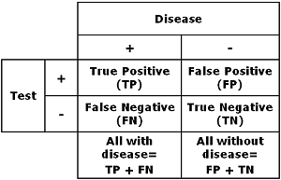

**You make a table like above you have to decide your cut-off for distinguishing healthy from sick.**

**The cutoff determines the clinical sensitivity and specificity.**

**When you change the cut-off, you have to get other values like Ture positive and negative or False positive and negative, but all disease is same and so the number of all without disease.**

**Thus you will get the increase in sensitivity or specificity at the expenses of lowering the other parameter when you change the cut-off [1].**

**A ROC curve is constructed by plotting the true positive rate (TPR) against the false positive rate (FPR). The True positive rate is the proportion of observations that were correctly predicted to be positive out of all positive observations (TP/(TP +FN)) . Similarly, the false positive rate is the proportions of observations (FP/(FP + TN)). For example, in medical testing, the true positive rate in which people are correctly identified to test positive for the disease in question.ss**

**A discrete classifier that returns only the predicted class gives a single point the ROC space. But for** probabilistic **classifier, which give a probability or score that reflects the degree to which an instance belongs to one class rather than another, we can create a curve by varying the threshold for the score. Note that many discrete classifiers can be converted to a scoring classifier by ‘looking inside’ their instance statistics.**